Document Title: Vignette Report
Author: Simon Bond
Date: 16:15 06 Nov 2025

Section: Baseline

Table 1.1.1 Summary Table
Note A
Population: Full (n = 4)
Variable | Statistics | Control | Drug | Total
aGe (yAars) | n | 3 | 1 | 4
 | Mean (SD) | 33.3 (11.7) | 56.0 ( NA) | 39.0 (14.8)
 | Median | 38 | 56 | 40
 | Min, Max | 20, 42 | 56, 56 | 20, 56
gender | Male | 1/3 (33%) | 1/1 (100%) | 2/4 (50%)
 | Female | 2/3 (67%) | 0/1 (0%) | 2/4 (50%)
fictitious data

Table 1.1 Summary Table
Note A
Population: Safety (n = 6)
Variable | Statistics | Control | Drug | Total
Age | n | 3 | 3 | 6
 | Mean (SD) | 33.3 (11.7) | 43.3 (21.1) | 38.3 (16.2)
 | Median | 38 | 55 | 40
 | Min, Max | 20, 42 | 19, 56 | 19, 56
Gender | Male | 1/3 (33%) | 2/3 (67%) | 3/6 (50%)
 | Female | 2/3 (67%) | 1/3 (33%) | 3/6 (50%)
fictitious data

Table 1.2 Regression: Age predicted by Treatment
Note A
Population: Safety (n = 6)
Parameter | Estimate (SE) | Conf. Int. | p-value
Mean age reference arm | 33.3 (9.85) | 6.00, 60.7 | 0.0276
Treament Effect | 10.0 (13.9) | -28.7, 48.7 | 0.5124
Residual SE | 17.1
Number of Observations | 6
fictitious data

Figure 1.3 Kaplan-Meier Plot
Note A
Population: Safety (n = 6)
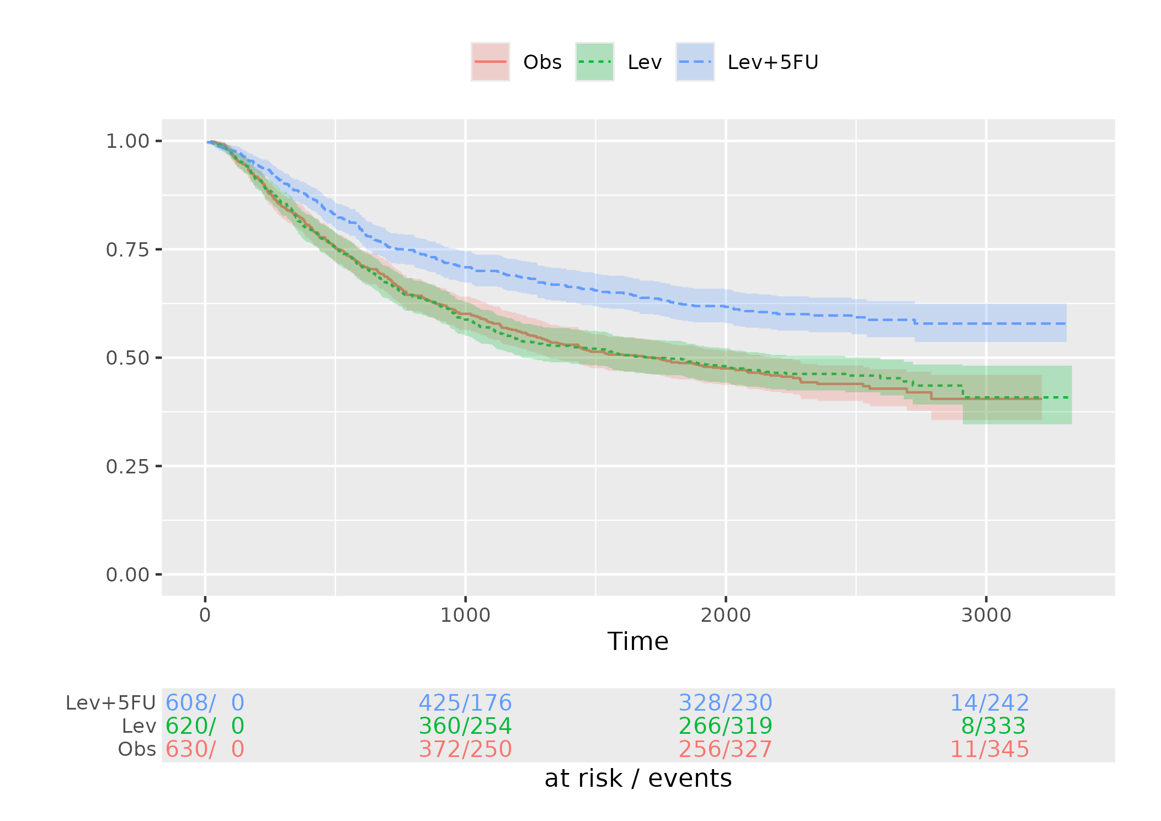
fictitious data

Figure 1.10 Summary Figure
Note B
Population: Safety (n = 6)
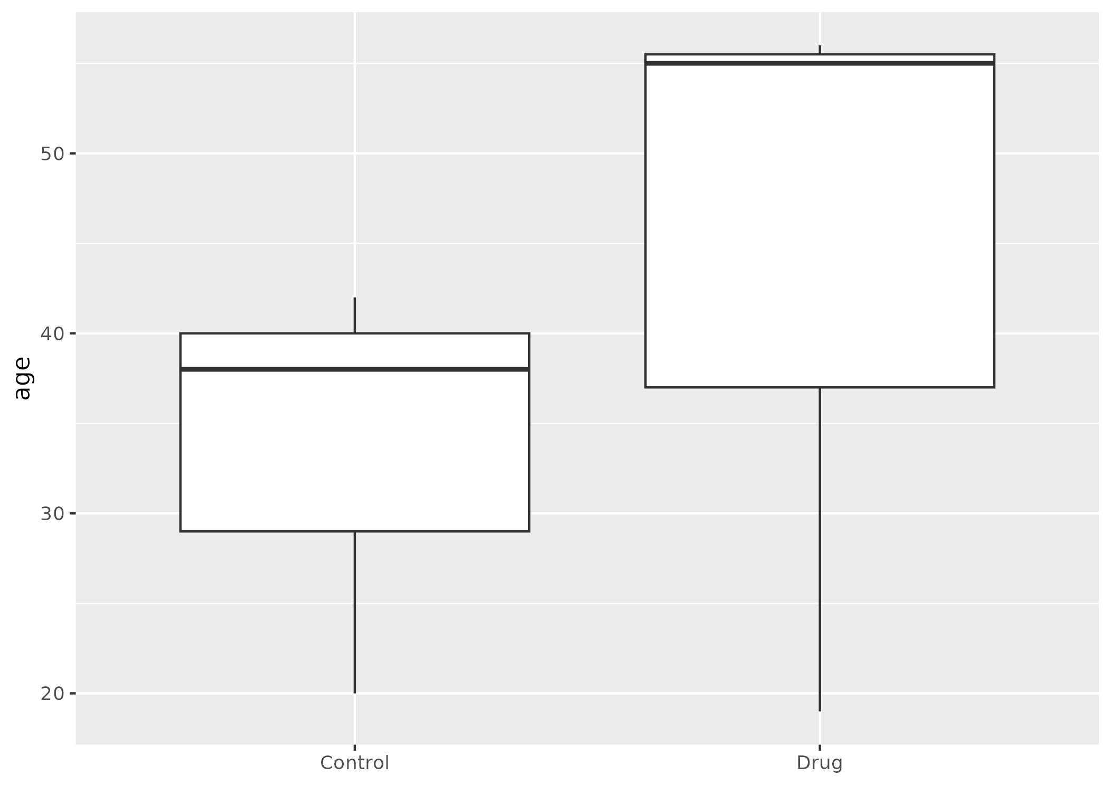

Section: Safety

Table 2 Deaths
Population: Safety (n = 6)
There were no deaths

Section: Meta

Table 9 Imported Data
Population: NA (n = NA)
name | file | folder | mod_time | full_file_path
data | dirtydata.csv | /home/runner/work/_temp/Library/cctu/extdata | 2025-11-06 16:14:19 | /home/runner/work/_temp/Library/cctu/extdata/dirtydata.csv
codes | codes.csv | /home/runner/work/_temp/Library/cctu/extdata | 2025-11-06 16:14:19 | /home/runner/work/_temp/Library/cctu/extdata/codes.csv

